Report Name
Snowflake vs. BigQuery Power BI Report Validation

1. Dashboard & Environment Details
Dashboard / Report Name
Semantic Model Name
Snowflake Work Space Name
GCP Work Space Name
Tester Name | Madhu Babu Mushtina
Validation Date | DD-MMM-YYYY
Overall Status | Pass✅

2. Filter Validation Log
- Check filters navigation and actions.
- After making filter selections In both Snowflake & GCP, check having same behavior and objects are rendering as expected or not (Take screenshot or add Description)
ID | Page / Tab Name | Action / Filter Applied | Expected Behavior | Result  (Pass/Fail)
01 | Landing Page | Time Period : All  Relative Time : Previous Week  District : All | Data was filtered based on the filters | Pass✅

2.1 Snowflake
ID : 01
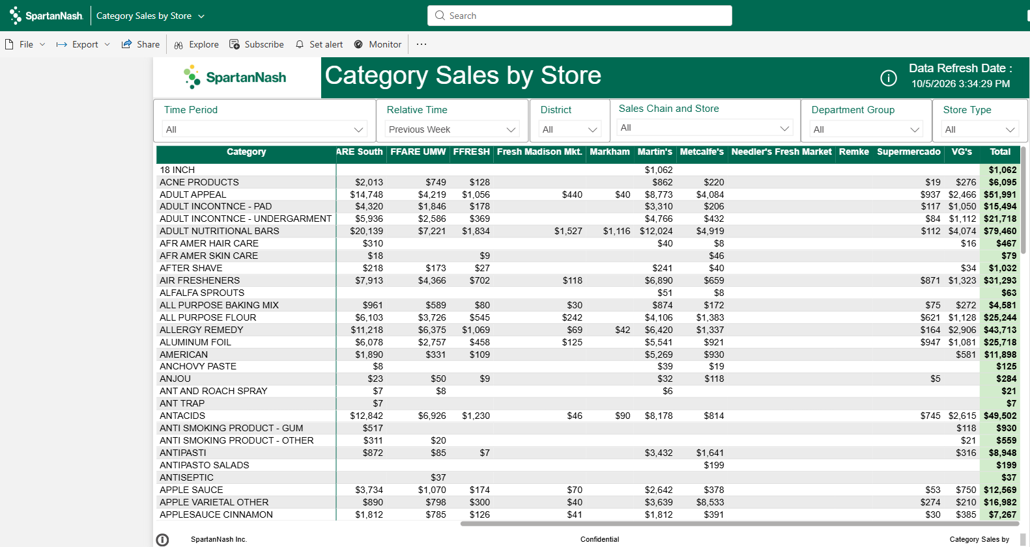

2.2 GCP
ID : 01
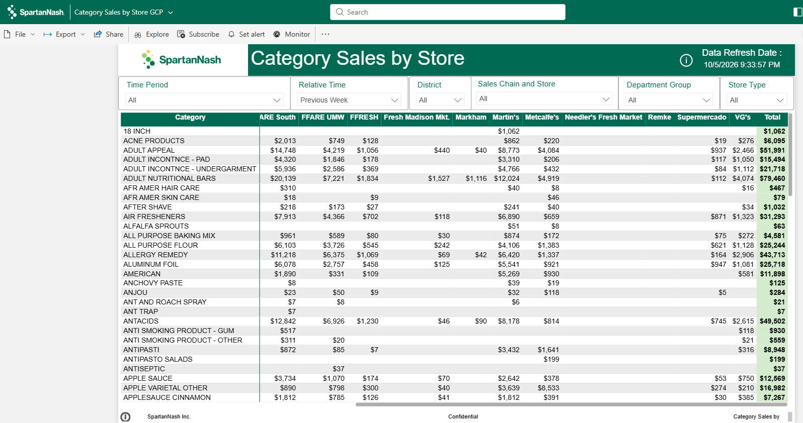

3. Visual & Functional Validation Log
Capture whether the report / object looks correct and whether the functionality behaves correctly or not (One Screenshot per tab)
ID | Page / Area | Visual Name | Action / Filter Applied | Expected Result | Result
01 | Landing Page | Table | Time Period : All  Relative Time : Previous Week | Filter are applied and visuals are working as expected | Pass✅

3.1 Snowflake
ID: 01

3.2 GCP
ID : 01
Note : Validate all report functionalities, including drill-down, actions, hyperlinks, page navigation, page-level filters, report-level filters, and other interactive elements, to ensure they function as expected.

Comments: Data matched accurately between Snowflake and GCP, with no data discrepancies identified during the validation process.

4. Summary & Sign-off
Sign-Off Status | Pass✅
Tester Name | Madhu Babu Mushtina
Sign-Off Date | 06-Oct-2026

